Curriculum Vitae, Scientific and Career Transcript
of
Prof. Salwa Mohammed Seleem
Professor of Medical Physiology Assiut Egypt
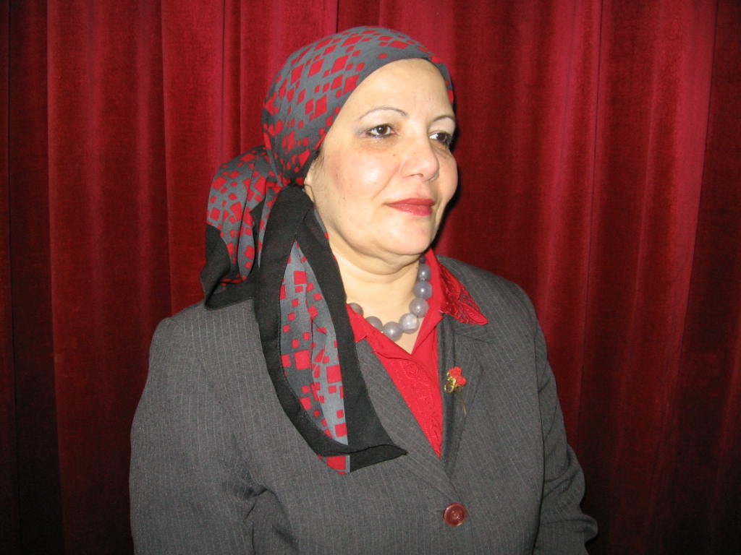
___________
Name : Salwa Mohammed Seleem.
Date of Birth 1/8/1949
Place of birth : Assiut-Egypt.
Nationality : Egyptian.
Marital Status: Married.
A- Scientific Transcript:
- M.B. B.CH, Faculty of Medicine, Assiut University, Assiut, 1973.
- M.Sc. “Physiology”, Faculty of Medicine, Assiut University, Assiut, 1982.
- Ph.D. “Physiology”, Faculty of Medicine, Assiut University, Assiut, 1986.
Title of Thesis: “Study on Plasma Pattern of Some Hormones in Upper
Egyptian Females, Normal and Abnormal Conditions”.

B- Career Transcript:
- August 2007 – Present: Head of Medical Physiology Department, Faculty
of Medicine, Assiut University, Assiut.
- Dec. 1997 – July 2007: Professor of Medical Physiology, Faculty of
Medicine, Assiut University, Assiut.
- Nov. 1991 - Dec.1997: Assistant Professor of Medical Physiology,
Faculty of Medicine, Assiut University, Assiut.
- August 1986-Nov.1991: Lecturer, Department of Medical Physiology, Faculty
of Medicine, Assiut University, Assiut.
- Jan. 1982 - Aug. 1986: Assistant Lecturer, Department of Medical
Physiology, Faculty of Medicine, Assiut
University, Assiut.
- 1975 - January 1982 :Demonstrator, Department of Medical
Physiology, Faculty of Medicine, Assiut
University, Assiut.
- 1974 - 1975 :Physician, Ministry of Health, Assiut, Egypt.

C- Scientific Activities:
I- Teaching:
a- Under-graduate courses:
1“Physiology of: Endocrine Glands, Urinary System, Digestive System and
Blood” 1st year students, Faculty of Pharmacy. (1986-2009)
2. “Physiology of Blood, A.N.S.”, (1987-1995)
3. “Physiology of: Endocrine Glands, Urinary System”,
2nd year students, Faculty of Veterinary. (1989-1990)
4.“Physiology of Endocrine Glands”,
1st year students, High Institute of Nursing (1988-1990)
5. “The A.N.S.”1st year students, Faculty of Medicine. (1990- 2009)
6. “Physiology of Blood”.1st year students,
Faculty of Medicine. (1990-2009)
7.“Physiology of Special Circulation”.
1st year students, Faculty of Medicine. . (1996-1999)
8. “External examiner of Physiology,
1st and 2nd year students, Faculty of Medicine, Minia University. (1987-1990)
9. Physiology of: Endocrine Glands, Urinary System, Digestive
System, Biophysics,A.N.S and Blood” 1st, 2nd,3ed, semester ,to Clinical
Pharmacy students, Faculty of Pharmacy. (2007 - 2009)

b- Post-graduate courses:
For the M.Sc. degree students of:
1.Department of Anesthesia. (1986- Present)
2.Department of Urology. (1988- Present)
3.Department of Obstetrics and Gynecology. . (1989-Present)

II- Supervision:

1. M.Sc.Thesis:“Effect of Prostaglandin E₂ on Arterial Blood Pressure in
Mature Male Rabbits”.
Department of Physiology, Assiut. (1986-1989)
2. M.Sc. Thesis: “Studies of Baroreflex Sensitivity in Adult Male Rabbits”.
Department of Physiology, Assiut. (1991-1994)
3.M.Sc. Thesis: “Biological Studies on Prostaglandin's and Oxytocins in
Pregnant and Non-Pregnant Rats” Department of
Physiology,Assiut. (1994-1996)
4.M.Sc. Thesis: “Study of Rhythm Disorder in Normal Individual
using Holter Monitoring”
Department of Medicine, Assiut. (1994-1996)
5.Ph.D. Thesis: “Evaluation of the Operative Laparoscopy in the
Management of Polycystic Ovarian disease”
5. Department of Gynaec. & Obst., Assiut. (1993- 1998)
6. Ph.D. Thesis: “Effect of ANP on Steroidogenesis and Kidney
Function Test in Adult Male Rats”.
Department of Physiology, Assiut. (1995-1999)
7. Assisting in the hormonal studies in:
a) M.Sc. Thesis: “Effect of Certain Stress Factors on Plasma Testosterone level in Male Rats”.
Department of Physiology, Assiut. (1989 )
b) Ph.D. Thesis: “Bromocriptine Therapy in Pre-Eclamptic Toxemia of
Pregnancy”.Department of Gynaec. and Obst.,
Faculty of Medicine,Sohag. (1988 )

III- Scientific Participation in Conferences:
- “Fifth Annual Scientific conference”, Faculty of Medicine,
Assiut University,23-24 April 1987.
“Melatonin Suppressive Effect on Testicular Activity”.
2. The “First Annual Conference on Medical Physiology”,
University of Zagazig, September 1988.
- “The effect of chronic Toxicity of Morphine and Propoxyphene on Testicular functions”. “Salivary Testosterone in Men of Upper Egypt”.
3.“XII World Congress of Gynecology and Obstetrics”, Rio de Janeiro, Brazil,
October 23-28, 1988.
- “Bromocriptine Therapy in Pre-Eclamptic Toxemia of Pregnancy (PET)”.
4. “Seventh Annual Scientific Conference”, Faculty of Medicine, Assiut University, 16-17 February 1989.
- “Early Sexual Maturation Induced by Pineal Extract”.
- “Effect of prostaglandin E₂ on Arterial Blood Pressure in Mature Male Rabbits”.
5.“The 16th Annual Meeting of the Egyptian Society of Cardiology”, Cairo
University, February 1989.
“Post-Myocardial Infarction Sexual Dysfunction”
6.“Seventh Annual Conference of Egyptian Society for Animal Reproduction and Fertility”. Faculty of Veterinary Medicine, Cairo University,21-23 January 1995.
- “Serum Progesterone and PGF_{2α} Levels in Friesian Cattle as Related to Uterine Involution and Post-Partium Ovarian Activity”.
7.“The First Israeli-Arab Scientific Meeting”, Paris-Sud University-Paris From 3-7 April, 1995.
- “Effect of changes in PGF_{2α} on Modification of Airway Response
among patients with Bronchial Asthma during Pregnancy”.
8.“Egyptian Soci, Lab. Med. Sixth Conference-Med. Lab. Performance
Upgrading”, Cairo International Conference Center, 3-5 January, 1995.
“Correlation of Prostatic Specific Antigen and Sex Hormone Binding
Globulin in Prostatic Carcinoma”.
9-The “Third Conference of Cattle Diseases” Faculty of Veterinary Medicine,
Assiut University, 3-5 December 1995.
- “Thyroid Activity in Egyptian Buffalo-Cows with Ovarian Inactivity and Trials for Treatment by Intrauterine Infusion of Lugol’s Iodine
Solution”.

IV- Scientific Activities Abroad:

1.Fellowship in the Department of Reproductive Physiology,
St. Bartholomew’s Hospital,Medical College, London University,
London, U.K. (6 weeks from 6th of July 1987).
2.”WHO” research training grant (special program for research in human
reproduction) for 6 months at the Singapore National University Hospital,
Department of Obstetrics and Gynecology to get a deep acquaintance
With laboratory techniques dealing with IVF.
3.Selected to be a member of the team in the Faculty to collaborate with a
counterpart French team in an IVF project (unaccomplished).
4.Fellowship in the Department of Reproductive Physiology, St.
Bartholomew’s Hospital, Medical College, London University, London,
U.K.(4 weeks, July 1995).
5. Fellowship in the Department of Reproductive Physiology,
St.Bartholomew’s Hospital, Medical College, London University,
London, month, June-Aug.1996).
6- Fellowship in the Department of Reproductive Physiology, Karolinska
Institute,Stokholm, Sweden with Professor Bygdmans
( August – October,2000).
7- Referee& Reviewer of King Abdel Aziz University, Jeddah, KSA (Medical
programs, Faculty of Medicine)

V- Studies and Research in Due Course:
The fields of Endocrinology, and in Reproductive Physiology In with Prof. T.Chard, Dept. of Reproductive Physiology, St. Bartholomew’s Hospital, West Smithfield, London, U.K. &Prof. Bygdmans, Department of Reproductive Physiology, Karolinska Institute, Stokholm, Sweden

VI- Books:

1.“Physiology of Blood”, for 1st year students, Faculty of Medicine.
2.“The Autonomic Nervous System”, for 1st year students, Faculty
of Medicine.
3.“Special Circulation”, for 1st year students, Faculty of Medicine.

VII- Membership of Scientific Societies:

1. The “Egyptian Society of Physiological Sciences”.
2. The “Egyptian Society of Tumor Markers Oncology”.

D- Languages:

- English: Fluently spoken and written.
- French: Good. Special Language Courses are followed up in the C.E.L.F.”
of Assiut University.

E- Some of Publications:

1-“Mechanism of Action of the Intrauterine Contraceptive Device: Evidence for a Specific Biochemical Deficiency in the Endometrium”.
Salwa M. Seleem*, F.A. Hills**, H.T. Salem***, E.M.El-Nashar*** and T. Chard**.
*Department of Physiology, Assiut University, Assiut, Egypt.
** Department of Reproductive Physiology, St. Bartholomew’s
Hospital Medical College, London, UK.
*** Department of Obstetric & Gynaecology, Assiut University,
Assiut, Egypt.
(Human Reproduction Vol. 11 No.6, pp. 1220-1222, 1996).

2- “Raised Circulating Levels of Interleukin-6 in Women with an Intrauterine Contraceptive Device”.
Jane A. Woolley*, Salwa M. Seleem**, Frank A. Hills***, Hosam Salem****, E. El-Nashar****, and T. Chard***
*Therapeutic Antibodies Ltd., St. Bartholomew’s Hospital Medical
College, London UK.
**Department of Physiology, Assiut University, Assiut, Egypt.
*** Department of Reproductive Physiology, St. Bartholomew’s
Hospital Medical College, London, UK.
****Department of Obstetric & Gynaecology, Assiut University,
Assiut, Egypt.
(Gynecol and Obstetric Investigation 1996; 42: 241-243).

3- “A Trial of Two Ovulation Regimens in Cases of Polycystic Ovarian Disease”.
Hassan S. Kamel* and Salwa M. Seleem**
Departments of Obstetrics & Gynaecology* and Physiology**, Faculty of Medicine, Assiut University, Assiut Egypt.
(Bull. Egypt. Soc. Physiol. Sci. 16 (1), pp. 221-234, 1996).

4- “Stress Responses During Lactation”.
Salwa M. Seleem*, and Hassan S. Kamel**
Departments of Physiology* and Obstetrics & Gynaecology**, Faculty of Medicine, Assiut University, Assiut, Egypt.
(Bull. Egypt. Soc. Physiol. Sci. 16 (2), pp. 301-318, 1996).

5- “ EFFECTS OF DEPOT PROGESTAGENS ON ENDOMETRIAL PROTEIN SYNTHESIS”
Diaa Eldeen M. Abd El Aal*,H.Salem*,Safwat A. Mohamed*,Hanan G. Abd El-Azeem**, Salwa Seleem*** and T.Chard****
*Department of Obstetrics&Gynecology, Faculty of Medicine,
** Departmentof clinical Pathology,*** Department of Physiology Faculty of Medicine Assiut University,Assiut, Egypt, and Department of Reproductive Physiology, St Bartholomew’s Hospital, London ,UK.
`

Domain of work: Reproductine Physiology &Gynecology (Mechanism of action of different contraceptive device through hormonal assay by different methods).

Time of expected visit: From 5th to 28th of February 2010 .

On my first visit to the Department of Reproductive Physiology, Karolinska Institute,Stokholm, Sweden with Professor Bygdmans
( August – October ,2000).We study the hormonal level at different cases of infertility.
On the second visit to Karolinska Institute,Stokholm, Sweden with Professor Bygdmans ( 3August – 26August,2009). We work on endometrial
receptivity and implantation .

Telephone office +20882332278 Assiut Egypt
Fax office +20882360606 Assiut Egypt
Telephone home +20882295455 Assiut Egypt
Mobile 0105212133 Assiut Egypt

Email: sseleem@hotmail.com

